LAB

REPORT

# IRE 212 : IoT Architecture and Technologies Sessional

|  |  |
| --- | --- |
| PREPARED BY  Mehrin Farzana  ID: 2101013  Session: 2021-2022  Date: 08/09/2024 | SUPERVISED BY  Suman Saha  Lecturer  Department of IRE, BDU |

|  |  |
| --- | --- |
| logo1 | BANGABANDHU SHEIKH MUJIBUR RAHMAN DIGITAL UNIVERSITY  (BDU) |
|  |  |

**List of Problems**

1. Temperature and Humidity Monitoring and Display Using Arduino and LCD in Tinkercad

**Problem No.:** 01

**Problem Statement:**

Temperature and Humidity Monitoring and Display Using Arduino and LCD in Tinkercad

**Code:**

#include <LiquidCrystal.h>

const int rs = 11, en = 10, d4 = 4, d5 = 5, d6 = 6, d7 = 7;

LiquidCrystal lcd(rs, en, d4, d5, d6, d7);

const int tempSensorPin = A0;

const int humiditySensorPin = A1;

int rawValue = 0;

double voltage = 0;

double tempC = 0;

double tempF = 0;

void setup() {

Serial.begin(9600);

pinMode(humiditySensorPin, INPUT);

lcd.begin(16, 2); // Initialize the LCD with 16 columns and 2 rows

lcd.print("Temp & Humidity");

delay(2000); // Delay to show the initial message

lcd.clear(); // Clear the screen

}

void loop() {

// Temperature reading

rawValue = analogRead(tempSensorPin);

voltage = (rawValue / 1023.0) * 5000; // Convert to millivolts

tempC = (voltage - 500) * 0.1; // Convert to Celsius

tempF = (tempC * 9 / 5) + 32; // Convert to Fahrenheit

// Display temperature on Serial Monitor

Serial.print("Raw Value = ");

Serial.print(rawValue);

Serial.print("\t Voltage = ");

Serial.print(voltage, 0);

Serial.print(" mV\t Temperature in C = ");

Serial.print(tempC, 1);

Serial.print(" C\t Temperature in F = ");

Serial.println(tempF, 1);

// Humidity reading

int humiditySensorOutput = analogRead(humiditySensorPin);

int humidity = map(humiditySensorOutput, 0, 1023, 10, 70);

// Display humidity on Serial Monitor

Serial.print("Humidity: ");

Serial.print(humidity);

Serial.println("%");

// Display temperature and humidity on LCD

lcd.clear();

lcd.setCursor(0, 0); // Set cursor to the first row

lcd.print("Temp: ");

lcd.print(tempC, 1);

lcd.print(" C");

lcd.setCursor(0, 1); // Set cursor to the second row

lcd.print("Humidity: ");

lcd.print(humidity);

lcd.print("%");

delay(5000); // Wait 5 seconds before next update

}

**Circuit:**

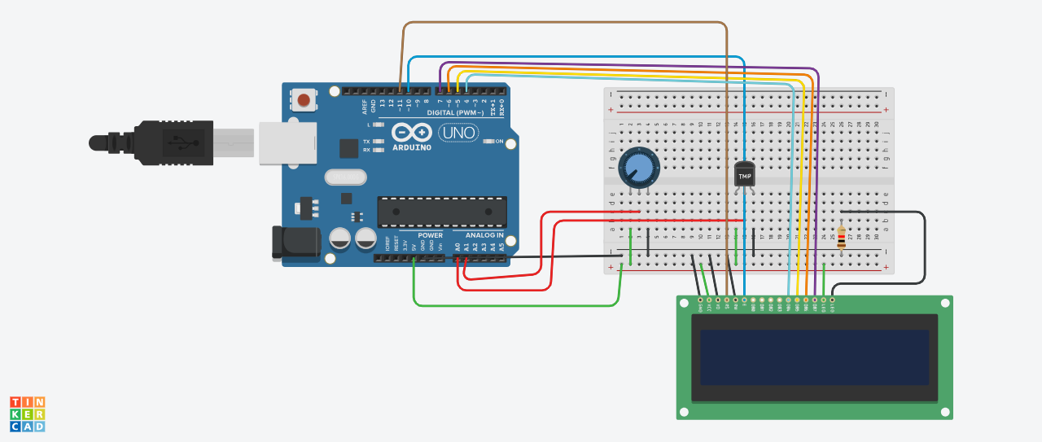

Figure 1.1: Circuit design on a simulator

**Output:**

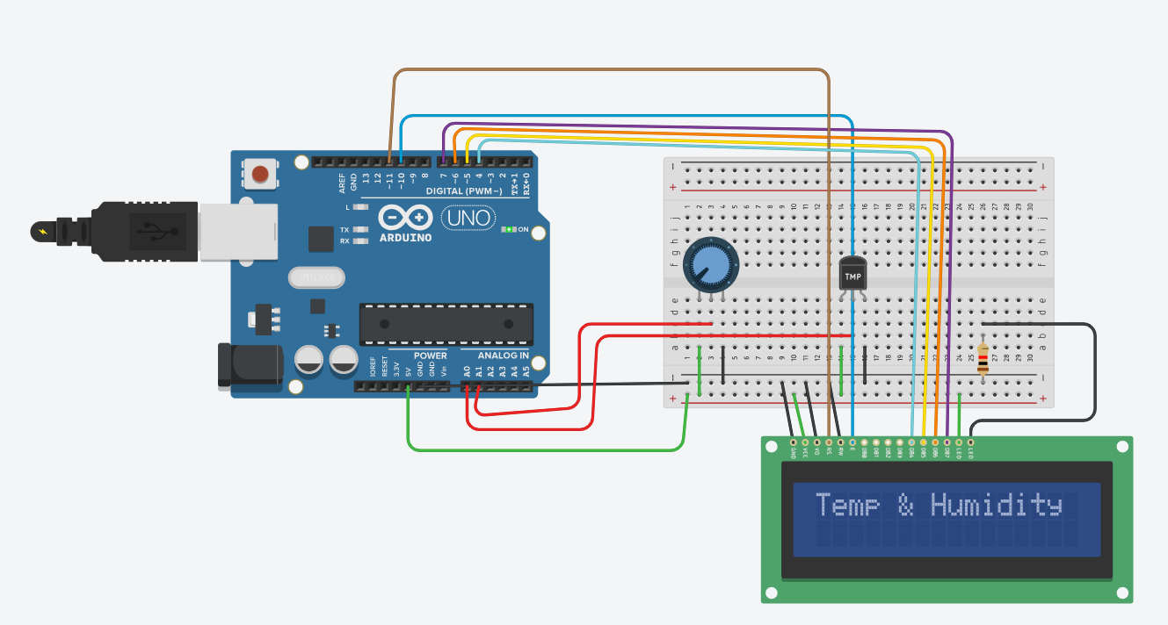

Fig 1.2: Output on simulator.

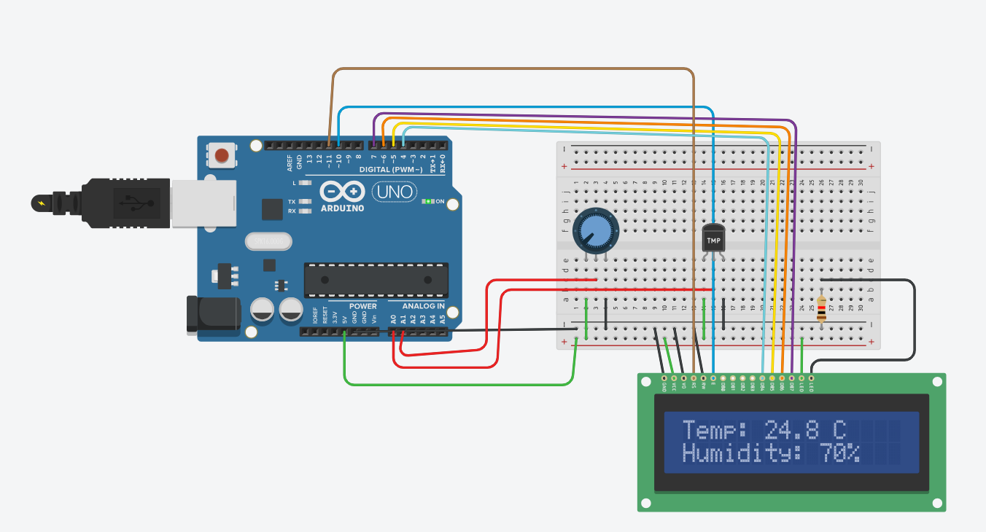

Fig 1.3: Output on simulator.